**Create a VM and Assign Delete Lock**

**Lab Steps**

**Task 1: Sign in to Azure Portal**

1. Go to the Azure portal by clicking on the **Open Console** button or by using the URL [https://portal.azure.com](https://portal.azure.com/).

**Task 2: Deploying a Virtual Machine**

1. From the Azure portal menu or from the Home page, select **Create a resource**.

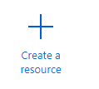

1. In the **Categories**select **Virtual Machine** and click on **Create.**

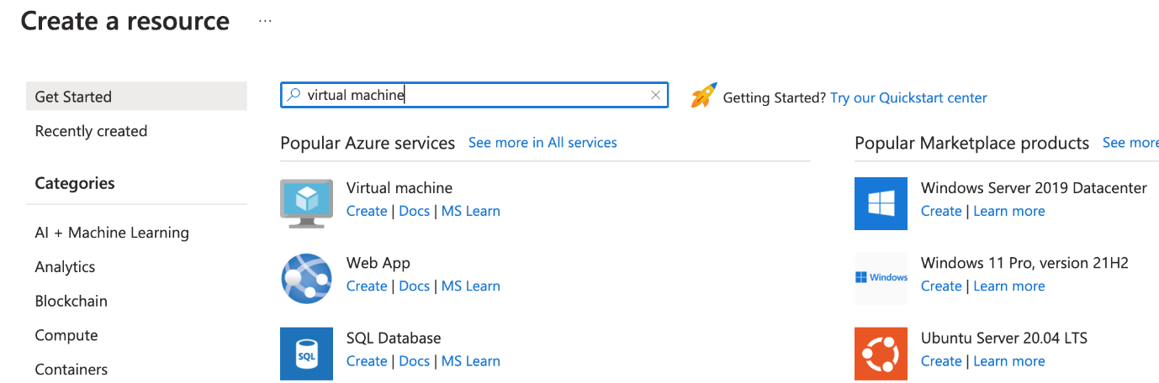

1. Fill out the **Create a Virtual Machine**basic details form with the following information

* Subscription: Select the subscription where you want to create the VM
* Resource group: Select the resource group where you want to create the VM
* Virtual Machine Name: Enter theVM Name
* Region: Select the region where you want to deploy the VM. Eg.: EastUS
* Image: Select the desired OS Image. Eg. Windows Server 2022 Data Centre Edition
* Availability Options: Select the required availability type for redundancy (None, Availability Zone, VM Scale Set or Availability Set

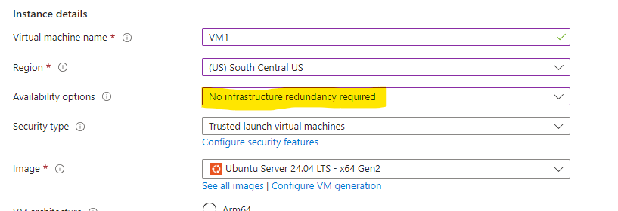Note: Depending on the option selected, you may get additional options. See Images Below:

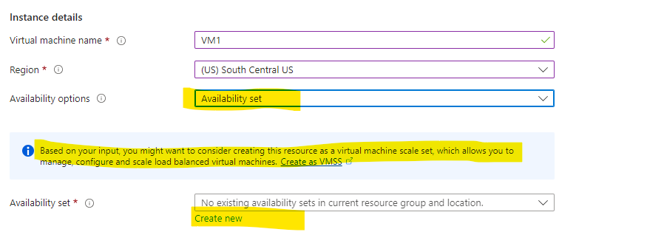

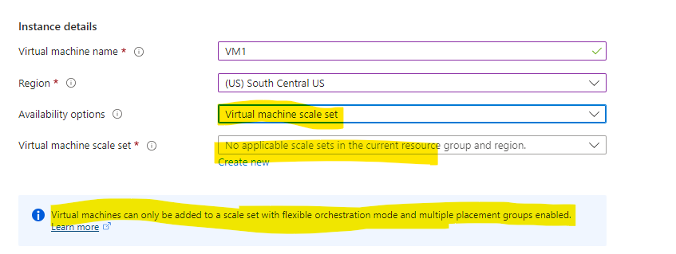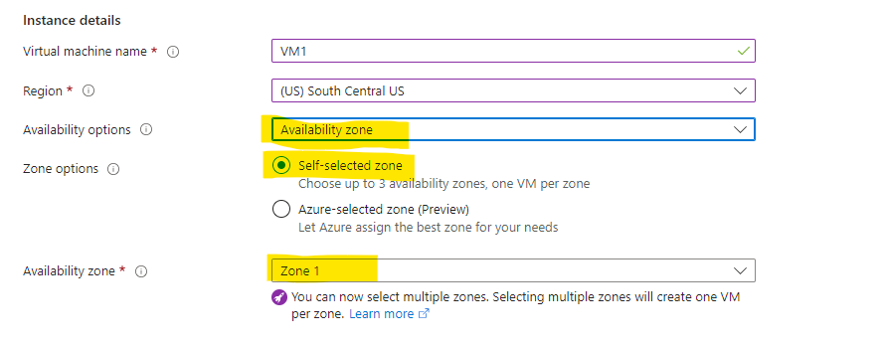

* If availability zone is selected, Select the number of zones for redundancy.
* Size: Click on **See all sizes** and select the required.

**Note: More Compute Power = More Cost**

* Select the **Authentication Type as Password** and Enter the Username, Password and confirm Password. (This will be used to login to the VM as an Admin)
* Select Inbound Port Rules: Select the desired port number for traffic to pass through. Eg: RDP 3389 or SSH 22 etc

1. 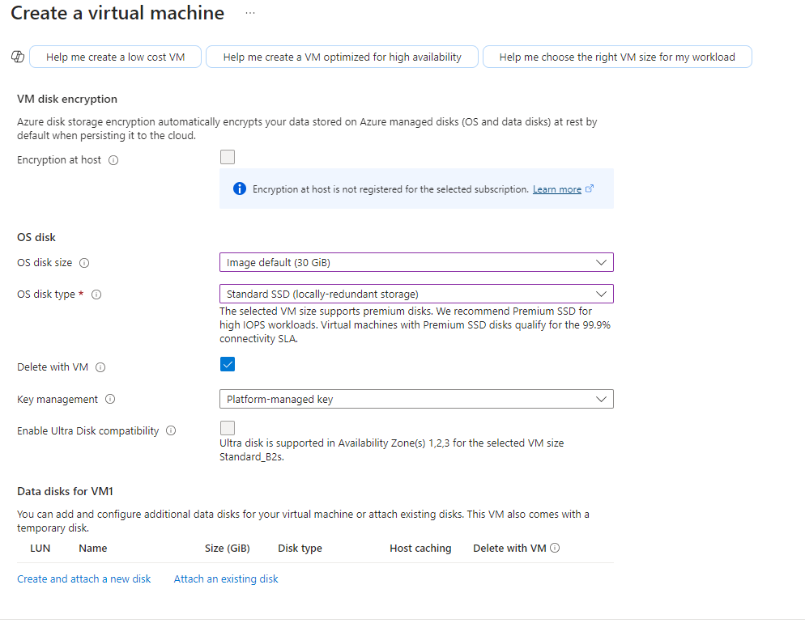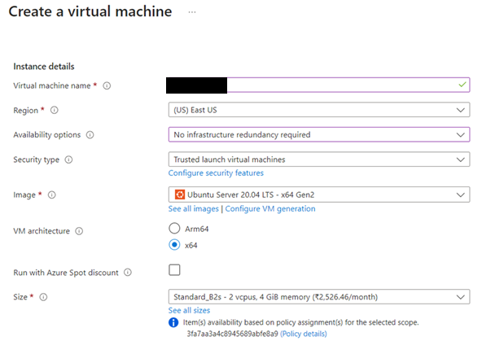In **Disks** tab, Select the disk size (Above Disk Size will be used to OS only).Select the Disk Type (Standard SSD/Premium SSD etc) You can also create additional disks in your VM for data storage by using the Data Disks for VM section in the same page
2. Now Click next to go to Networking Tab**.** (VNet, Subnet are important as without it, VM cannot be used in a network).

* Select an existing Virtual Network or Create one
* Select an existing Subnet from the existing Virtual Network or Create a new if new Virtual Network is created. (You will have the option to create a new subnet while creating a new Virtual Network)
* Select the NSG for NIC
* Select the Allowed Ports

1. Now that we have all the basic requirements to create a VM Hit, review and create.

**Note: If you want to explore more options like EntraID, Auto Shutdown, Boot Diagnostics, Tags etc you can explore the additional tabs.**

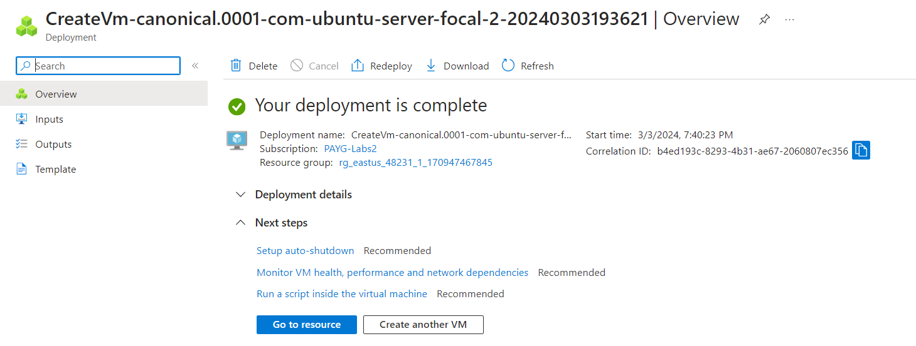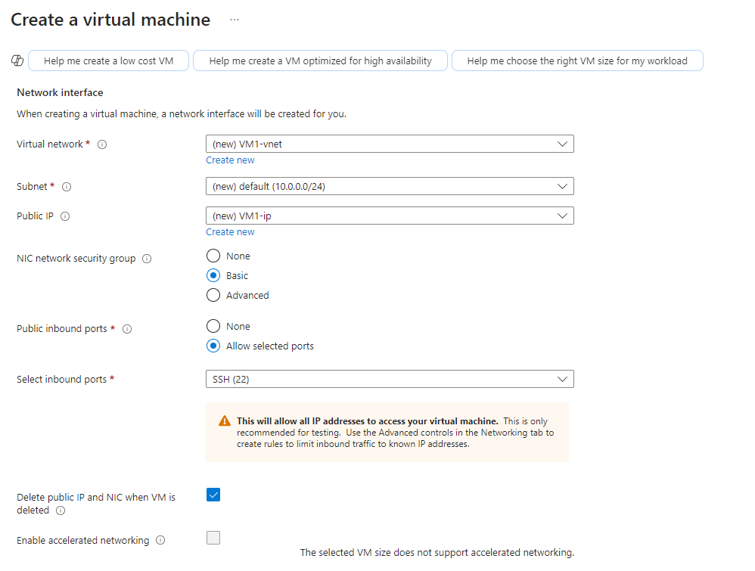**If you want to deploy any applications automatically with the VM, you can go to Advanced Tab and Click on *Select a VM Application to Install.***

**Task 3: Creating a Delete Lock**

1. 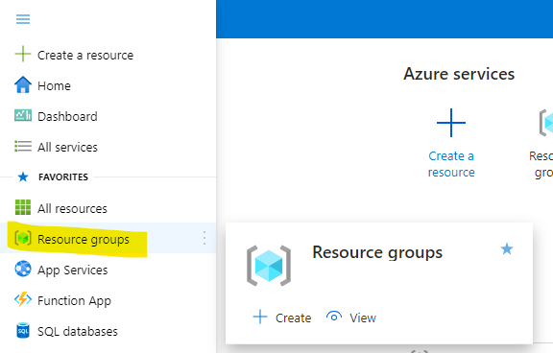In the Azure Portal, On the Top Left Hit the Burger Icon and Click o Resource Group > Select the Resource Group where the VM is created.

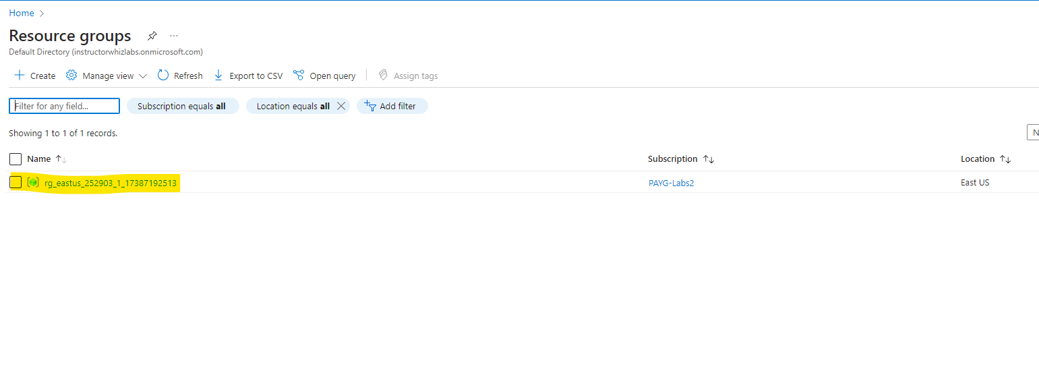

1. Click on the Virtual Machine you just created, and in the left panel under the Settings, click on **Locks**and then click **Add.**
2. Fill the form named **Add lock** with the following details:

* Lock name: Enter the desired name for the lock
* Lock Type: Select **Delete**
* Click **OK.**

***Note: Two Types of Locks can be created. Read Only and Delete. I am assigning Delete Lock.***

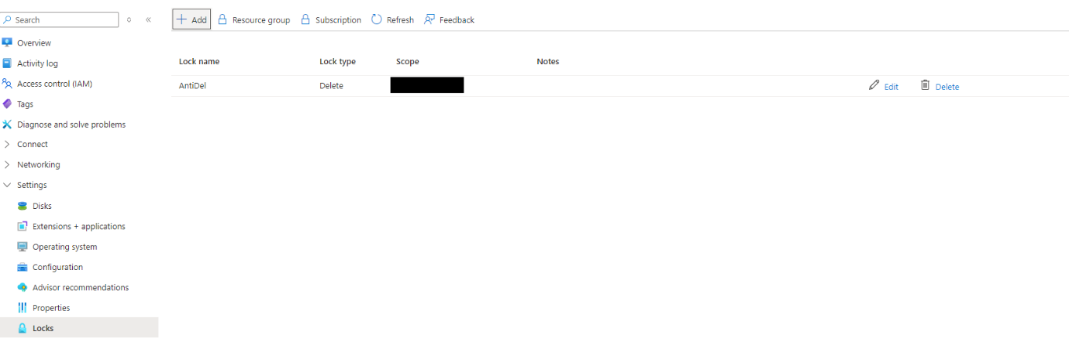               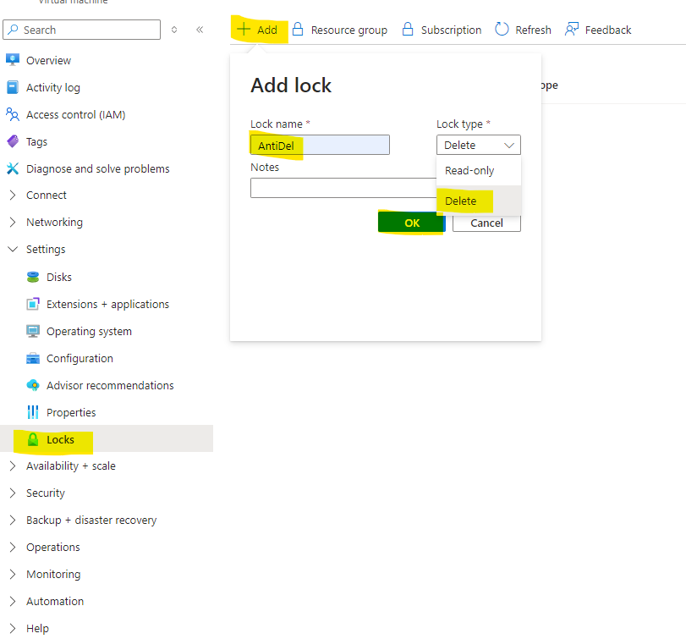

1. Now, If you try to delete the Virtual Machine, you will get the following error:

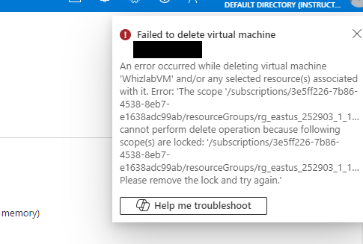

**If you get the above error, then you have successfully applied the Lock.**

**Task 4: Delete the Resource Lock and Delete the Virtual Machine with its associated resources.**

* 1. Follow the same steps as above to go to the Lock Section of the Virtual Machine
  2. You should see the Lock created earlier
  3. 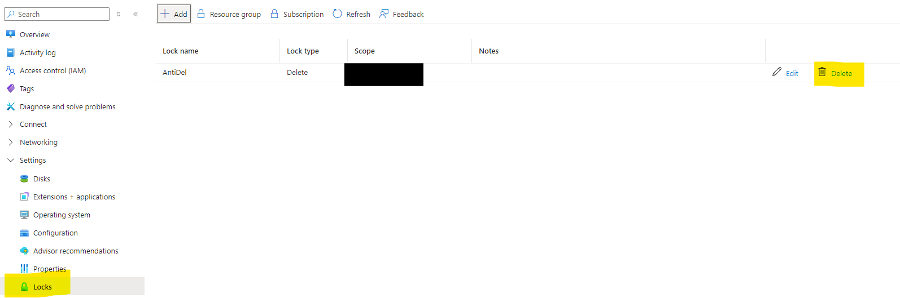Hit Delete
  4. Now go to Overview page of the Virtual Machine and Hit Delete. You will be able to successfully delete the VM